Suggested language for youth audience
You can have influence! You can get trained! You can get paid!

YNOT is calling on all young Tasmanians aged 18-25 to get involved in the Tasmanian Youth Voice Network pilot project.

The Network aims to support meaningful engagement of young people in government policy discussions, strategic planning and decision-making. By sharing your opinions, ideas and experiences, you can help shape policies, programs and/or services that affect you and other young people.
As a Network member, you will hear about opportunities to participate in paid consultations and free online training workshops that aims to build your skills and confidence to have a say on issues important to you.

Sign up today to have your voice heard! https://www.ynot.org.au/tasmanian-youth-voice-network

Suggested language for general audience
YNOT is calling on all young Tasmanians aged 18-25 years to get involved in the Tasmanian Youth Voice Network pilot project! The Youth Voice Network aims to support meaningful engagement of young people in government policy discussions, strategic planning and decision-making.

By sharing their opinions and experiences, young Tasmanians can help shape policies, programs and/or services that affect young people. As a Network member, young people will hear about opportunities to participate in paid government consultations and free online training workshops that aims to build their skills and confidence to have a say on matters important to them.

Sign up or find out more here: https://www.ynot.org.au/tasmanian-youth-voice-network

Social Media Tile V1 1080x1080
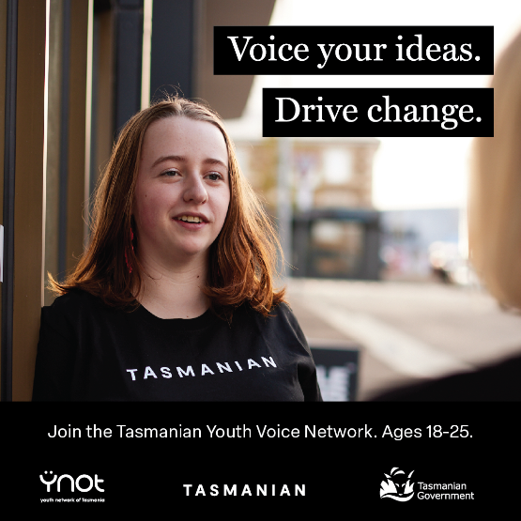

Social Media Tile V2 1080x1080

Social Media Tile V3 1080x1080

Email footer 820 x 312

High-Res Version 3417x1300
